=Ideation Phase

Define the Problem Statements

Date | 01 February 2026
Team ID | LTVIP2026TMIDS24613
Project Name | DocSpot: Seamless Appointment Booking for Health
Maximum Marks | 2 Marks

Customer Problem Statement
- Who is experiencing the problem?
Patients seeking timely medical care and doctors managing consultations
- What are they trying to accomplish?
Patients often struggle to book doctor appointments conveniently. They face issues such as:
- Long waiting times at clinics.
- Difficulty in finding available doctors nearby.
- Lack of transparency in doctor availability and consultation fees.
- Missed or forgotten appointments due to poor reminders.
- Limited options for rescheduling or canceling appointments.
Doctors, on the other hand, face challenges like:
- Inefficient scheduling and overlapping appointments.
- Difficulty in managing patient records and histories.
- Missed opportunities to optimize consultation time.

Why does it matter?
Healthcare is time-sensitive. Delays or inefficiencies in booking appointments can lead to:
  - Scam listings or jobs with unclear expectations and poor compensation
  - Missed opportunities for early diagnosis and treatment.
  - Reduced trust in healthcare providers.
  - Increased patient anxiety and dissatisfaction.
  - Operational inefficiencies for doctors and clinics

What does the customer need?
Patients need a simple, reliable, and transparent way to book, manage, and track doctor appointments. Doctors need a streamlined scheduling system that reduces administrative burden and improves patient care.
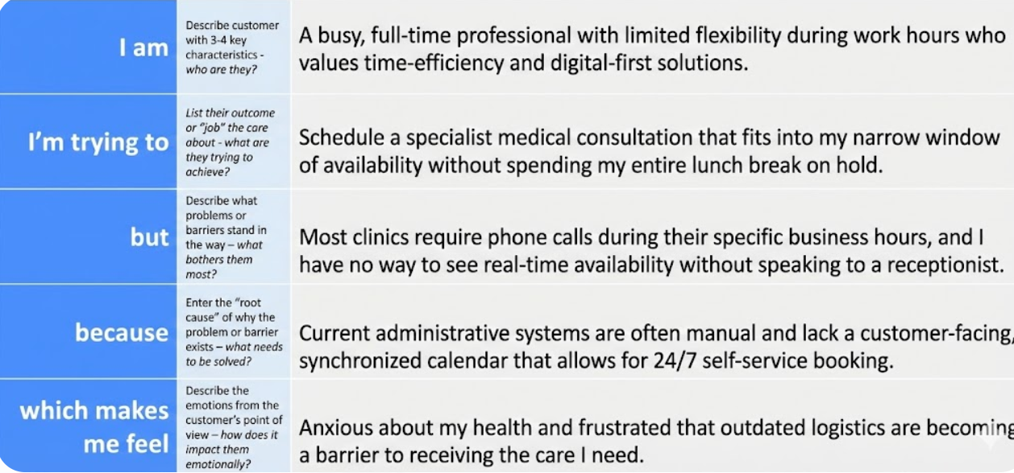

Problem  Statement (PS) | I am  (Customer) | I’m trying to | But | Because | Which makes me feel
PS-1 | a working professional with a tight schedule | book a doctor’s appointment quickly without phone calls or long wait  times. | most clinics don’t have real-time booking systems or clear availability  info | their systems are outdated or fragmented | frustrated and anxious about my health getting worse while waiting.
PS-2 | a general physician running a small clinic. | manage patient bookings efficiently and reduce no-shows. | my current tools are manual or not tailored to healthcare  workflows. | I cannot afford or understand complex clinic manageme-  nt systems. | stressed and underpaid despite my busy schedule.

